**Project Memo**

The project is currently close to completion. It is not, however, fully completed. The program does not have reporting and search. Setting up the build script was something I definitely underestimated. I tried converting my project to Maven for easier building and testing resulted in 6 hours of trying to compile the project and tests and ended in deleting the project and recovering it from GitHub.

**GitHub repo**

https://github.com/yanimihaylov/CS445.git

**Lines of Code:**

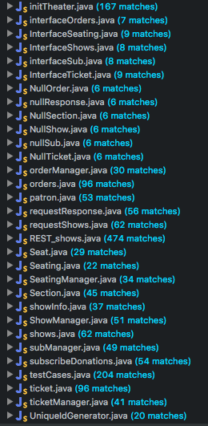

**Total Lines of Code:**

1617 (excluding testCases.java)

**Unit Test Coverage:**

56.5% (not my greatest work.)

**Number of hours to get code working**

I believe I have spent about 60-65 hours of work to get the code in its current state.

**Hours spent preparing the submission**

I have been preparing the build of the project for about 12 hours total. I ran into numerous setbacks creating a build script that incorporates tests.

**Challenges that were faced include:**

The first problem was to figure out how to make HTTP requests. I remembered I had used an application called Postman that helped me immensely in developing the project. It allowed me to save requests and be able to quickly troubleshoot problems.

I relied on StackOverflow for the majority of the problems I faced.

The build script was, I’d say, my biggest challenge. I spent a lot of time trying to get Maven to work and I ended up reverting back to an older “non-mavenized” version of my code and continue trying to get ANT to work. Overall it was an interesting project and I will most definitely continue working on it and finish it fully after I submit it and after the semester ends.

**Comments:**

I really enjoyed the class and this project. I feel like I learned a lot and there has rarely been projects where I willingly stayed up until 5 in the morning for because I want to work on it.